**Speech Recognition using Google Speech Recognition Engine**

**Equipment:**

Logitech H111 Stereo Headset

**Sample speech text [obtained from Wikipedia]:**

Mizuho Bank Limited is the integrated retail and corporate banking unit of Mizuho Financial Group, one of the largest financial services companies in Japan, with total assets of approximately $1.8 trillion in 2017.

**Python codes:**



**Output results:**

1. **Transcription**

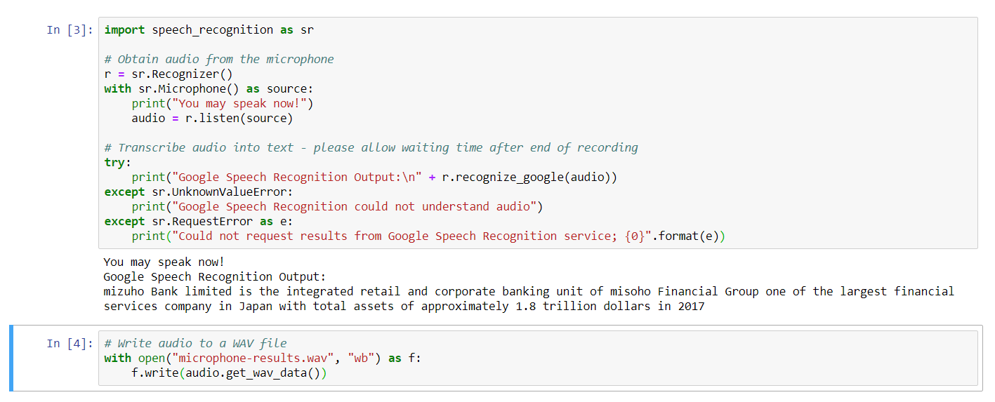

1. **Voice file**

